Container Lifetime & Persistent Data

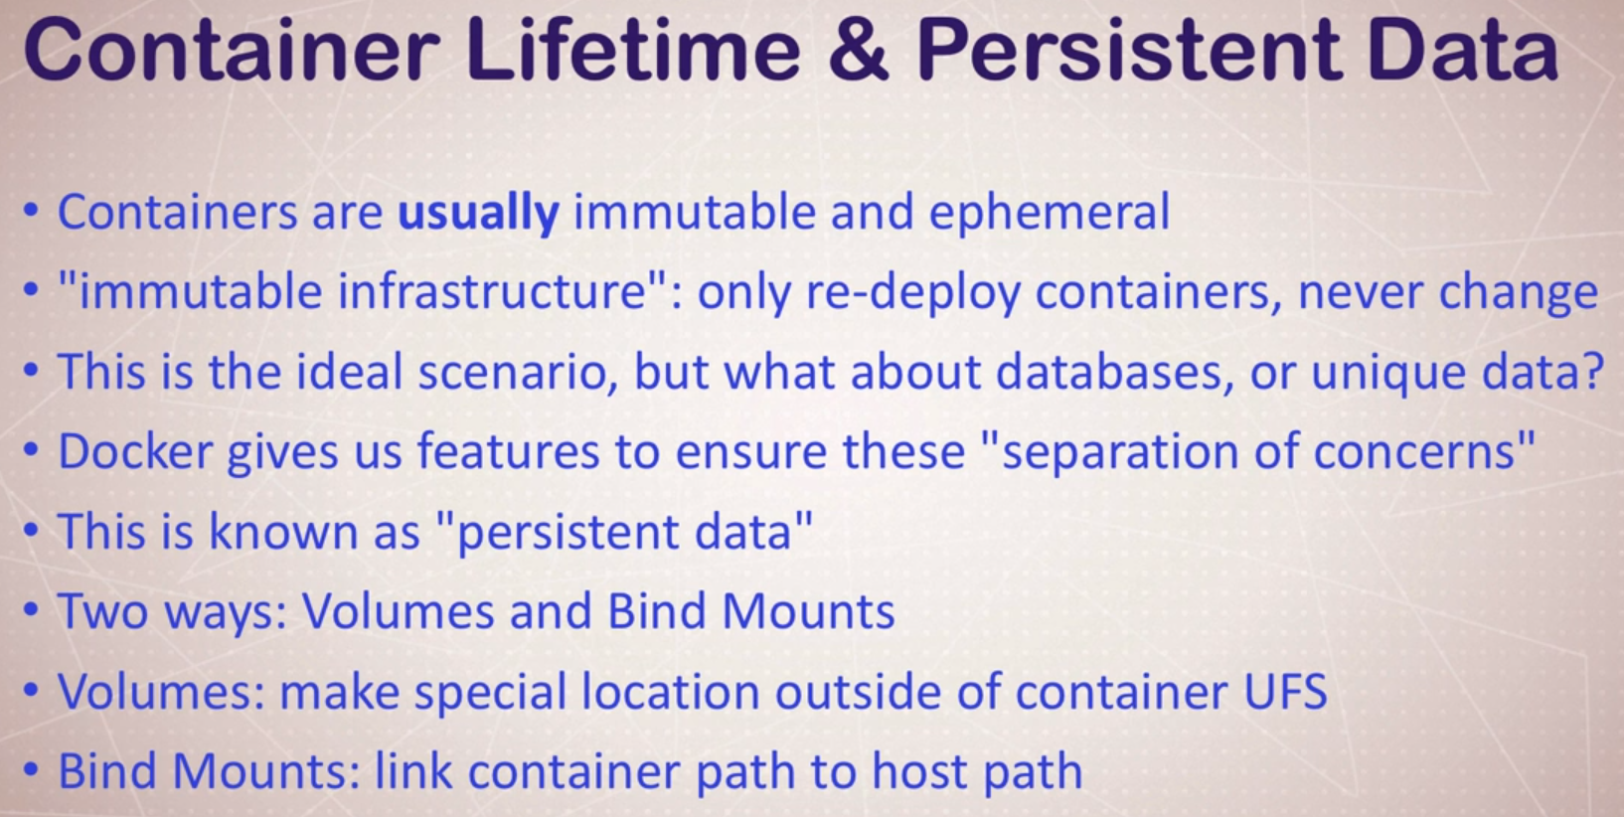

Removing Images doesn’t remove the volumes

1. docker run -d --name mysql -e MYSQL_ALLOW_EMPTY_PASSWORD=True mysql (Run mysql image 1)
2. docker run -d --name mysql2 -e MYSQL_ALLOW_EMPTY_PASSWORD=True mysql (Run mysql image 2)
3. docker volume ls

DRIVER VOLUME NAME

local 1b34918c28fb5beee777bdf342d5f623e06d46c8235cdc9bc723150a636873b2

local 4cc88c61cb2a77ed3f3ff74d85b05c91d70d615deb0be9147f7f52a647091c98

local 8a3c8e5d17b0807051f1e3ee6ccea26acff196b5d36e799a5406de7fda90b631

local 8b4fc719259eee5118a7a4d874685600f0cf6bc7b1917bc75c17074c588da1ff

local 8ef64882b106ef59a3a9ca423354c89c5c5240edd0fb8fce0ab3b60c809aebda

local 416654ca1e66868e2b9e05c78ed34c8ef4a7769f04ff0ade89dc31945708bb60

local d097faffcdf092a3cb3240e54f2a44c8c01520f8a8e76f151e1638d8eb8df4b7

local ec1b5d16233f3c68179d71d19f57c3350bd215dd8e6f024c1f84b75c7c8c7c6d

local f3f20cedb2cb6fabec5f3a4d2fcc9cfcc37a4dcf402f3e1c659befb28d41105e

local f94afd63c9547f2a50326e0b95ea2526643d8ee24a9d56864c629b94a524bbf3

local f435ba5c7a10eac2bcef4b7c4d3fc87e508ac3fa5bde734c33ad211a9a29f26d

1. docker container ls

CONTAINER ID IMAGE COMMAND CREATED STATUS PORTS NAMES

8719d6db1c12 mysql "docker-entrypoint.s…" 6 minutes ago Up 6 minutes 3306/tcp, 33060/tcp mysql2

f3ef373a4e57 mysql "docker-entrypoint.s…" 16 minutes ago Up 16 minutes 3306/tcp, 33060/tcp mysql

1. docker container rm -f mysql mysql2

CONTAINER ID IMAGE COMMAND CREATED STATUS PORTS NAMES

1. docker volume ls

DRIVER VOLUME NAME

local 1b34918c28fb5beee777bdf342d5f623e06d46c8235cdc9bc723150a636873b2

local 4cc88c61cb2a77ed3f3ff74d85b05c91d70d615deb0be9147f7f52a647091c98

local 8a3c8e5d17b0807051f1e3ee6ccea26acff196b5d36e799a5406de7fda90b631

local 8b4fc719259eee5118a7a4d874685600f0cf6bc7b1917bc75c17074c588da1ff

local 8ef64882b106ef59a3a9ca423354c89c5c5240edd0fb8fce0ab3b60c809aebda

local 416654ca1e66868e2b9e05c78ed34c8ef4a7769f04ff0ade89dc31945708bb60

local d097faffcdf092a3cb3240e54f2a44c8c01520f8a8e76f151e1638d8eb8df4b7

local ec1b5d16233f3c68179d71d19f57c3350bd215dd8e6f024c1f84b75c7c8c7c6d

local f3f20cedb2cb6fabec5f3a4d2fcc9cfcc37a4dcf402f3e1c659befb28d41105e

local f94afd63c9547f2a50326e0b95ea2526643d8ee24a9d56864c629b94a524bbf3

local f435ba5c7a10eac2bcef4b7c4d3fc87e508ac3fa5bde734c33ad211a9a29f26d

Default Volume Names are not friendly; So, we can use a **Named Volume**

1. docker run -d --name mysql4 -e MYSQL_ALLOW_EMPTY_PASSWORD=True **-v mysql-db:/var/lib/mysql** mysql
2. docker volume ls

DRIVER VOLUME NAME

local 1b34918c28fb5beee777bdf342d5f623e06d46c8235cdc9bc723150a636873b2

local 4cc88c61cb2a77ed3f3ff74d85b05c91d70d615deb0be9147f7f52a647091c98

local 05a2da0acba4cef18c19d9de0d0b0f817a985bb292d98d0c6721b907d8bafc54

local 8a3c8e5d17b0807051f1e3ee6ccea26acff196b5d36e799a5406de7fda90b631

local 8b4fc719259eee5118a7a4d874685600f0cf6bc7b1917bc75c17074c588da1ff

local 8ef64882b106ef59a3a9ca423354c89c5c5240edd0fb8fce0ab3b60c809aebda

local 416654ca1e66868e2b9e05c78ed34c8ef4a7769f04ff0ade89dc31945708bb60

local d097faffcdf092a3cb3240e54f2a44c8c01520f8a8e76f151e1638d8eb8df4b7

local ec1b5d16233f3c68179d71d19f57c3350bd215dd8e6f024c1f84b75c7c8c7c6d

local f3f20cedb2cb6fabec5f3a4d2fcc9cfcc37a4dcf402f3e1c659befb28d41105e

local f94afd63c9547f2a50326e0b95ea2526643d8ee24a9d56864c629b94a524bbf3

local f435ba5c7a10eac2bcef4b7c4d3fc87e508ac3fa5bde734c33ad211a9a29f26d

local mysql-db